

July 24, 2023

TO WHOMSOEVER IT MAY CONCERN

This Certification proves that ADITYA JADHAV has completed the internship program at ‘DIVYANSH CONULTANCY SERVICES’ as a Web Designer.

She/He started the program from June 7, 2023 To July 22, 2023.

During his/her stay in the company as an intern, he/she displays enthusiasm, leadership, self-discipline and self-motivation.

We are glad to have him/her as one of our interns before and we would like to wish him/her all the best

Sincerely,

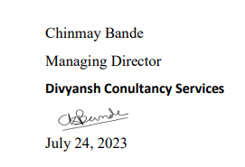 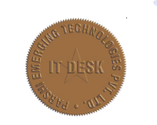





Franchise Center-Divyansh Conultancy Services



7/1, Sector No 29, Shreyash chaitanya park, building Dharmaraj chowk, Sant Namdev Marg, Ravet Near pradhikaran ,Gurudwara colony, New tunnel, Pimpari, Chinchwad, Ravet, Pune, Maharashtra

**Phone : +91 - 7048506032**